12/10/21

12:18AM

When New Item is different in older version

I’m creating a new item by right clicking on Models folder the rest explains in the screenshot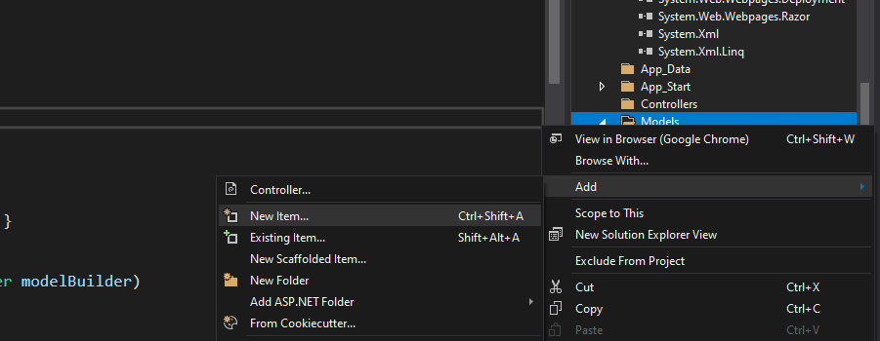I need to pick an item called ADO.NET Entity Data Model in the Data node. 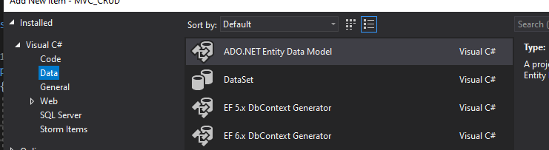

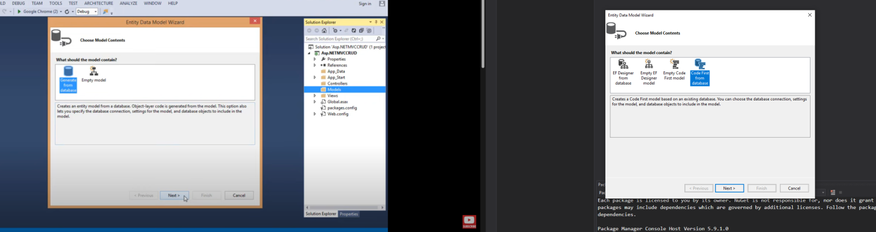Left pic is the tutorial vid from 2017 and the right pic is mine. The left chooses “Generate from database” while I choose “Code First from Database” and they have same paths but not exactly is the same. But it did generate the way I wanted just like in the tutorial.

12:29AM

How to Add Connection

I always baffled on this part where I couldn’t proceed because I don’t know what to do.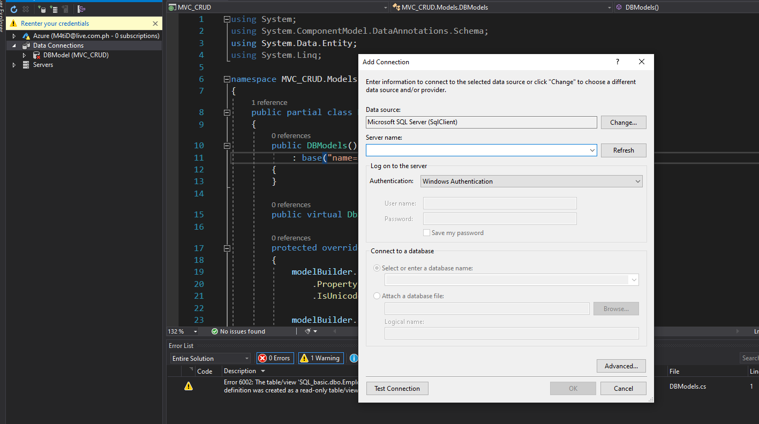I always complained that I already had a server in the SQL manager running but the server name failed to recognize it. I expect it to pop up on its own and not seeing it there means it didn’t work. Right now, I found out I can just type the server name manually instead of the system itself detecting it. 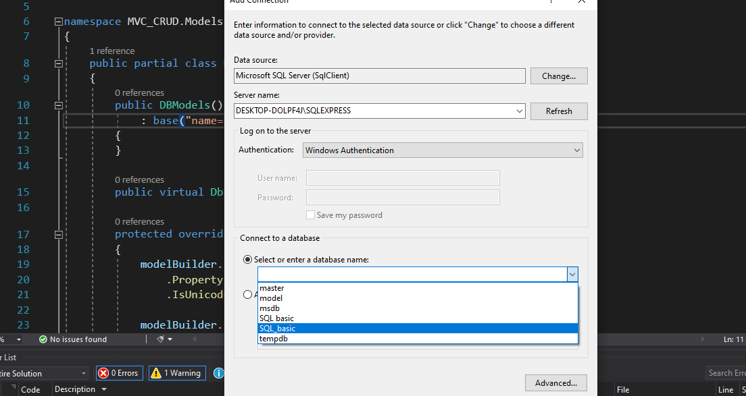after typing it, I was able to find the database that I was looking for called SQL_basic. I never knew this way would work. Hehehehehe….